Energy Transfer Operations
ECH 3223 (Class #11347)
Class Periods: Monday / Wednesday / Friday, Period 4 (10:40 – 11:30 a.m.)
Location: CSE E220
Academic Term: Spring 2026

Instructor:
Jason E. Butler
Professor, Department of Chemical Engineering
205B Materials Engineering
butler@che.ufl.edu
(352) 392-2591
Office Hours: Mondays and Wednesdays, 2:30 – 3:30 p.m. or by appointment

Course Description
Steady state conduction in solids and heterogeneous materials, transient conduction, convection heat transfer, heat transfer during boiling and condensation, radiation heat transfer, design of heat-transfer equipment and heat exchange networks

Course Pre-Requisites:
COT 3502 and ECH 3264.

Course Objectives
- Knowledge of the basics of heat transfer including Newton's law of cooling, Fourier's law, and concepts concerning heat transfer coefficients and dimensionless numbers.
(2) Derivation of a mathematical description of heat transfer problems using shell balances or heat diffusion equation in Cartesian, cylindrical, and spherical coordinates.
(3) Be able to solve unsteady and multi-dimensional heat transfer problems using the knowledge of the equations of change and knowing how to perform separation of variables and/or similarity transformations.
(4) Learn how to design heat exchanger networks and evaporators.

Materials and Supply Fees
N/A

Relation to Program Outcomes (ABET):

Outcome | Coverage*
- An ability to identify, formulate, and solve complex engineering problems by applying principles of engineering, science, and mathematics | High
- An ability to apply engineering design to produce solutions that meet specified needs with consideration of public health, safety, and welfare, as well as global, cultural, social, environmental, and economic factors | High
- An ability to communicate effectively with a range of audiences
- An ability to recognize ethical and professional responsibilities in engineering situations and make informed judgments, which must consider the impact of engineering solutions in global, economic, environmental, and societal contexts
- An ability to function effectively on a team whose members together provide leadership, create a collaborative and inclusive environment, establish goals, plan tasks, and meet objectives
- An ability to develop and conduct appropriate experimentation, analyze and interpret data, and use engineering judgment to draw conclusions
- An ability to acquire and apply new knowledge as needed, using appropriate learning strategies | Medium
*Coverage is given as high, medium, or low. An empty box indicates that this outcome is not covered or assessed in the course.

Required Textbooks and Software
- T.L. Bergman, A.S. Lavine, F.P. Incopera, D.R. DeWitt, Fundamentals of Heat and Mass Transfer, 8th Edition, Wiley 2018, ISBN 978-1-119-35388-1
- You must have a hard copy of the textbook. Some quizzes and exams will be open book, but online or electronic versions will not be permitted during assessments. Older editions are acceptable.
- You may not write notes in the textbook, as it will be used during exams. You may highlight or underline text and mark pages for quick access only.
- Working version of python is required in order to do the computer project.

Recommended Materials
• Bird, Stewart, Lightfoot, Transport Phenomena 2nd Ed, Wiley (2002)
• Welty, Wicks, and Wilson, Fundamentals of Momentum, Heat, and Mass Transfer
4th Ed, Wiley (2000)

Course Schedule and Important Dates
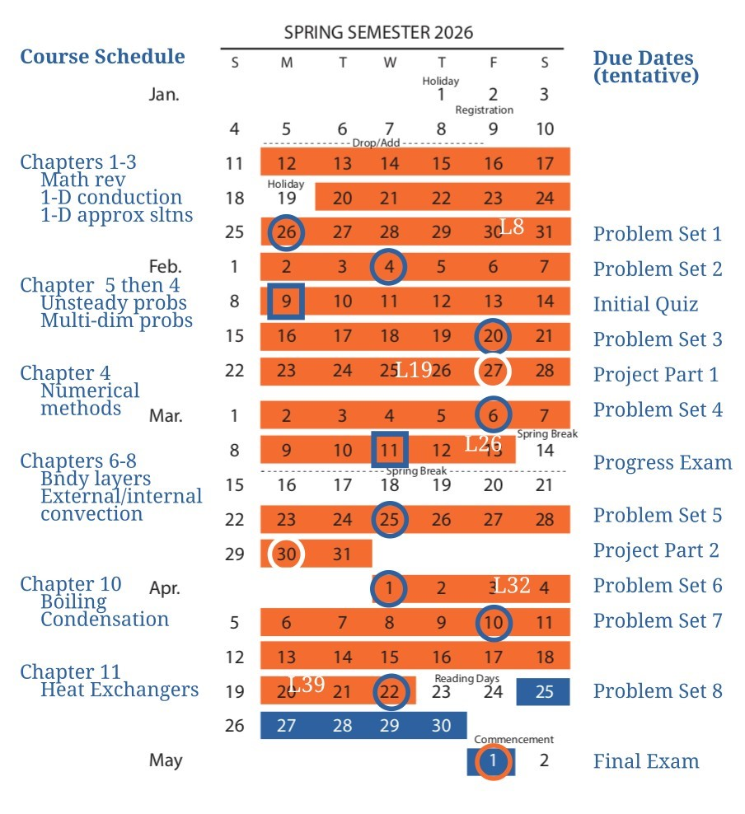
- Initial quiz in class (1 hour long) on February 9 (subject to possible change).
- Progress exam, tentatively on March 11 (2 hours, place and exact time will be announced),
- Final Exam on 5/1/2026 @ 7:30 - 9:30 a.m.
- Note that problem sets are not graded. Solutions will be posted on the completion date so that you may check your own work.

Attendance Policy, Class Expectations, and Make-Up Policy
- Class attendance is strongly recommended but not required.
- Requests for make-up exams will be considered only for those students who missed due to an acceptable reason as listed in the undergraduate catalog (link below).
- Students arriving late for an exam will be given only the balance of time remaining to complete their work unless an acceptable reason is provided (see Academic Resources link).

Evaluation of Grades
Assignment | Percentage of Final Grade
Numerical Project | 10%
Initial quiz | 20%
Progress Exam | 35%
Final Exam | 35%

Grading Policy
Percent | Grade | Grade Points
>85% | A | 4.00
80 - 84.9% | A- | 3.67
75–79.9% | B+ | 3.33
70–74.9% | B | 3.00
65–69.9% | B- | 2.67
60–64.9% | C+ | 2.33
55–59.9% | C | 2.00
<54.9% | C- | 1.67

Some notes on grading:
- The instructor guarantees these grades if you earn the posted percentages.
- The instructor may decide to lower the percentage thresholds required to attain the grades listed above, based on overall course performance and assessment difficulty.
- The instructor will not raise grade thresholds above those listed here.
- A score of C, or better, is needed to progress in the chemical engineering program.

Academic Policies & Resources
To support consistent and accessible communication of university-wide student resources, instructors must include this link to academic policies and campus resources: https://go.ufl.edu/syllabuspolicies. Instructor-specific guidelines for courses must accommodate these policies.

Commitment to a Positive Learning Environment
The Herbert Wertheim College of Engineering values varied perspectives and lived experiences within our community and is committed to supporting the University’s core values.

If you feel like your performance in class is being impacted, please contact your instructor or any of the following:

- Your academic advisor or Undergraduate Coordinator
- HWCOE Human Resources, 352-392-0904, student-support-hr@eng.ufl.edu
- Pam Dickrell, Associate Dean of Student Affairs, 352-392-2177, pld@ufl.edu

