Fluid and Energy Transfer Operations Laboratory
(Unit Operations Lab 1)
ECH 4224L

- Sections, Days, and Class Periods:
  - 2449 – Monday, periods 6 – 9 (12:50 – 4:55 pm)
  - 3535 – Tuesday, periods 2 – 5 (8:30 am – 12:35 pm)
  - FETL – Wednesday, periods 6 – 9 (12:50 – 4:55 pm)
- Locations: Unit Operations Lab (NSB 304 & 312)
- Academic Term: Spring 2026

Any student switching sections or adding to the class during the add/drop week must notify the course instructor as soon as possible.
Instructor:
Dr. Fernando Mérida
You can call me Prof./Dr. Mérida, or just Fernando if you feel comfortable. Calling instructors by their names must encompass the same level of professionalism and respect as using professional titles.
- e-mail: fmerida@ufl.edu
- Office Phone Number: (352) 294-7504
- Office Hours: Monday and Wednesday, 9:00 - 10:30 am Zoom
- You must book a 15-minute slot using this Google Calendar.
- Office hours can be either individual or group. If you have consultations that may benefit other team members, coming to office hours as a group is strongly encouraged.
- When booking your slot please delete the information shown in the "What" field and replace it by the following: your name & last name, section & team#, and a few words describing what you want to discuss during office hours. An example is available under the “description” field in the Google calendar.

Communications with and from Dr. Mérida:

- E-mail is my ONLY communication platform. Please do NOT message via Canvas messages.
- E-mail Subject Line: use this generic label: UO1 -Day#- Question Here, “Day#” refers to the day you’re enrolled in the course and your team number: Mon for Monday, Tue for Tuesday, and Wed for Wednesday. “Question” must be replaced by a few words describing your consultation.
  - Example: UO1-Wed#3- FLU – Pressure Drop Charts can be the subject line for a question dealing with chart choices for a student enrolled in team # 3 of the Wednesday section, who is currently analyzing data from the fluid flow (FLU) module.
- Response Time: you should expect a response within 48 hours (M-F) and within 72 hours (weekends). Failure to use the subject line above indicated will lead to delayed responses.
- Canvas Announcements will be periodically posted on Canvas. You must configure Canvas settings in order to get Canvas notifications during the term.

Peer Tutors:
- Please use peer tutor for undergraduate or graduate lab assistants that will supervise the execution of experiments. Avoid calling them “TA.
- You may contact peer tutors through Canvas messages or via e-mail (see Table 1 on page 2). Modifications to the list of peer tutors and their assigned experiments may be required. Canvas announcements will be posted if this happens.

Lab Staff:
- Lab Engineer: Mr. Preston Towns, ptowns@che.ufl.edu
- Lab Director and Unit Ops 2 course instructor: Dr. LiLu Funkenbusch, lilu.funkenbusch@ufl.edu

Table 1. Peer tutors for Unit Ops 1

Module | Monday | Tuesday | Wednesday
FLU  (Fluid Flow) | Connor Osmond  osmondc@ufl.edu | Sing To  tos@ufl.edu | Austin Sawyer  sawyeraustin@ufl.edu
HEX  (Heat Exchangers) | Danielle Loftis  dloftis@ufl.edu | Danielle Loftis  dloftis@ufl.edu | Holden Williams  h.williams1@ufl.edu
DIF  (Liquid & Gas Diffusion) | Ciara O’Grady  ciara.ogrady@ufl.edu | Cecilia Rodriguez  crodriguez17@ufl.edu | William Hernandez  hernandezw@ufl.edu
TFF  (Tangential Flow Filtration) | Austin Sawyer  sawyeraustin@ufl.edu | Jasmeet Bhatt  jasmeetbhatt@ufl.edu | Danielle Loftis  dloftis@ufl.edu
CCR  (Heat Conduction, and Convection/Radiation) | Cecilia Rodriguez  crodriguez17@ufl.edu | Benjamin Bermudez  benjaminbermudez@ufl.edu | Cecilia Rodriguez  crodriguez17@ufl.edu

Course Description
(2 credits) Experimental work in fundamentals of unit operations involving heat and momentum transfer.

Course Pre-Requisites
ECH3101 (Process Thermodynamics), ECH3203 (Fluid and Solid Operations), ECH3223 (Energy Transfer Operations), and STA 3032 (Engineering Statistics) or STA 2023 (Introduction to Statistics I)

Course Co-Requisites
ECH 4714 (Chemical Process Safety) and ENC2254 (Professional Writing in the Disciplines)

Materials and Supply Fees: $100.24

Course Objectives
- Reinforce classroom theory by the collection and use of data in practical experiments with all their inherent problems and limitations.
- Gain proficiency in writing technical reports, technical memos, and poster sessions.
- Gain experience in teamworking, time management, decision making, and troubleshooting
- Create a sense of professional responsibility for the quality and integrity of engineering work.
- Work safely thus promoting a safe environment for others.
- Learn equipment, instrumentation, and procedures not covered in lecture courses.
- Learn and apply basic concepts of statistical analysis and design of experiments whenever is possible.

Relation to Program Outcomes (ABET):

Outcome | Coverage*
- An ability to identify, formulate, and solve complex engineering problems by applying principles of engineering, science, and mathematics | High
- An ability to apply engineering design to produce solutions that meet specified needs with consideration of public health, safety, and welfare, as well as global, cultural, social, environmental, and economic factors
- An ability to communicate effectively with a range of audiences | High
- An ability to recognize ethical and professional responsibilities in engineering situations and make informed judgments, which must consider the impact of engineering solutions in global, economic, environmental, and societal contexts | Low
- An ability to function effectively on a team whose members together provide leadership, create a collaborative and inclusive environment, establish goals, plan tasks, and meet objectives | High
- An ability to develop and conduct appropriate experimentation, analyze and interpret data, and use engineering judgment to draw conclusions | High
- An ability to acquire and apply new knowledge as needed, using appropriate learning strategies | Medium

*Coverage is given as high, medium, or low. An empty box indicates that this outcome is not covered or assessed in the course.

Course websites
- Canvas: http://elearning.ufl.edu/
Canvas will be used as the main repository of resources for preparation of experiments, submission of lab homework, projects, and other deliverables. It will also be used for the posting of grades, announcements, and general information for the class. Please note that due to the inability of Canvas to properly weigh assignments with bonus, final grades will be computed externally by the course instructor.

- CATME
This software will be used for two purposes: a) group formation during first week of the semester, and b) team evaluations. Additional instructions are available in Canvas.

Recommended Literature:
There is no required textbook for this class. The following titles are recommended to support fundamentals and theoretical background, physical constants, empirical correlations, and other concepts:

- Geankoplis, C. J., Transport Processes and Unit Operations [On reserve in the Science Library].
- Incropera, F. P. and D. P. DeWit, Fundamentals of Heat and Mass Transfer [On reserve in the Science Library]
- Gerhart, Philip M., Gerhart, Andrew L., and Hochstein, John I, Munson’s Fluid Mechanics [On reserve in the Science Library]
- McCabe, W. L., J. C. Smith, and P. Harriet, Unit Operations of Chemical Engineering [On reserve in the Science Library]

Course overview
- Modules: this course consists of five modules with experiments designed to strengthen fundamental topics of fluid mechanics, energy transfer operations, and molecular transport.
- Rotations: each module is designed to last two weeks*. This two-week period is called rotation as student teams will rotate through all modules during the term. In each rotation, teams will be performing experiments pertaining to different modules.
- Names, nomenclature, and a brief description of experiments are listed in Figure 1.

* An exception to the two-week duration of each rotation will be that of rotation 5.

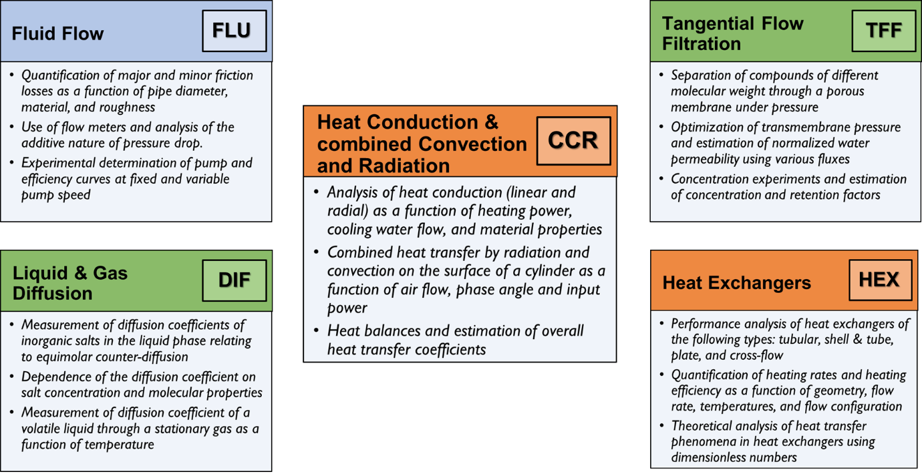

Figure 1 – Brief description of the experimental modules in ECH4224L

Student teams
- The number of members per team is planned to be four. However, a few teams might have 3 or 5 members depending on final enrollment at the end of the add/drop period
- Team formation will be done via CATME Team Maker Survey using instructor-determined criteria. Priority will be given to students’ similar free times outside the class.
  - Failure to complete this survey by the deadline will result on zero points. Additionally, you will put you on a random team whose time availability you must match.
  - If you cannot attend the Orientation Session due to justifiable reasons or got enrolled in this course during the add/drop period (but after the Orientation Meeting), you must contact the course instructor as soon as possible.
- Each team will prepare and sign a team contract to define the team’s mission, overall goals, commitment, resources, boundaries, constraints, etc. Team contracts will be prepared and signed by each member of a team on the second week of classes.
- Team composition will remain the same throughout the semester.
- Regardless of individual contributions, each team member is responsible for understanding all elements of each experiment including theory, experimental design, system configuration, experimental protocol, etc. in the different modules.

Required Computer
Please refer to the UF student computing requirement (https://news.it.ufl.edu/education/student-computing-requirements-for-uf/).
- All modules will require using student laptops at some extent during the lab period, mainly to review preliminary calculations. Guidelines for the use of laptops and other electronics in the lab are given in the Safety section.
- It is recommended that you use a PC and not a Mac.

Course Schedule

The schedule of course activities is summarized in Figure 2. Refer to Figure 1 for the three-letter abbreviation of experimental modules. Modifications to the proposed schedule may be necessary depending on performance of lab equipment/instrumentation, class cancellation due to atmospheric phenomena, or other reasons not listed in this document. These modifications include (but not restricted to) the addition, removal, or expansion of experiments. Announcements will be posted on Canvas regarding any modification of the course schedule.

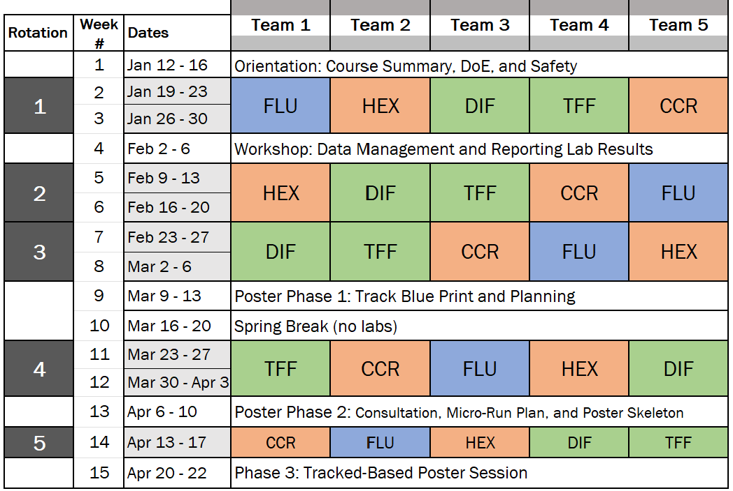

Figure 2 - Proposed schedule for all activities of ECH4224L

Attendance Policy, Class Expectations, Tardiness, Absences, and Make-Up Policy

Attendance to ALL class activities including experiments, sessions, tours, workshops, presentations, etc. indicated in Figure 2 is mandatory. There are NO excuses except for those qualifying as excused.

- Tardiness: students must be on time for all course activities (labs, sessions, lab tours, workshops, poster sessions, etc.)
  - A first tardiness within 10 minutes after starting the class: this will involve a “warning” and will only slightly affect participation grade. No need for documentation, but the student must inform their teammates while heading to lab and inform the course instructor when arriving. In case of an uncontrollable situation or emergency, the student must notify team members and course instructor as soon as possible within the day (see above for excused absences)
  - A second case of tardiness within 10 minutes after starting the class: this will result on a 3% overall grade reduction in the course, unless appropriate documentation is presented to justify the tardiness (see Excused Absences)
  - A third case of tardiness within 10 minutes after starting the class: this will result in a failing grade (D) in the course (see Evaluation of Grades), unless appropriate documentation is presented to justify the tardiness (see Excused Absences)
  - Tardiness 10 minutes after starting the class and before 10:00 AM might be categorized as excused only if justifiable (see “Excused Absences”) and appropriate notification is sent to the course instructor within the day of the tardiness, whenever is possible. Otherwise, the tardiness will become an unexcused absence (see “Unexcused Absences”).

- Excused absences: In case of foreseeing an absence due to justifiable reasons like those listed below, the student must e-mail the course instructor (copying the peer tutor) at least three days before the missed class. Excused absences must be consistent with university policies in the undergraduate catalog and will require appropriate documentation. Furthermore, any missed classes must be made up (see Make Up Policy)

  - Examples of excused absences include medical appointments/procedures, job interviews, national sport competitions, attendance to conferences, and other activities. For more information click here: https://catalog.ufl.edu/ugrad/current/regulations/info/attendance.aspx
  - Unexpected events or emergencies: the student must notify the instructor as soon as possible about to inform about the event/emergency preventing them from attending class.

Note: The course instructor might file a UMatter WeCare report in case the student does not notify the absence within the day it occurs. This procedure is done to ensure that students are safe.

- Unexcused absences: these can be absences (planned or unplanned) that cannot be justified with appropriate documentation.
  - Examples of unexcused absences: oversleeping, not hearing the morning alarm, deliberately not wanting to attend the class, not submitting pre-lab before starting a new module, or any other unreasonable situations. This list is not exhaustive and may include other examples.
  - One case of unexcused absence will result on 10% grade reduction and the missed class must be made up (see Make Up Policy). Keep in mind that making up the missed class will not remove any grade deduction or penalty associated with the absence.
  - A second case of unexcused absence will lead to a failing grade (D) in the course (see Evaluation of Grades)
- Make Up Policy: Any missed lab or class activity, whether excused or unexcused, must be made up.
  - Dates and logistics for making up a lab or class activity will be coordinated between the student and the course instructor. Make up sessions might include in-person or at-home activities. Keep in mind that making up a lab will not remove any grade deduction or penalty associated with the absence (e.g., unexcused absences) as explained above.
  - Failure to make up the missed class, even when the student notified the instructor with the appropriate documentation (whenever it applies), will result on 5% grade reduction.

Requirements for class attendance and make-up exams, assignments, and other work in this course are consistent with university policies. Click here to read the university attendance policies:
https://catalog.ufl.edu/UGRD/academic-regulations/attendance-policies/

Evaluation of Grades

Table 3. Grade distribution.
Assignment | Points | % Final Grade
Assessments (2) & Surveys (2); 15 io & 10 points each | 50 | 5%
Pre-labs (4); 40 points each | 160 | 16%
Progress Analysis (4); 60 points each | 240 | 24%
Lab Memos (4); 90 points each | 360 | 36%
Poster Session Project** | 150 | 15%
Participation | 40 | 4%
Total Points and Final Grade % | 1000 | 100%

Important: Grades for individual and group assignments, and other class activities described in Table 3 will be posted on Canvas. However, the final grade will be computed outside of Canvas to avoid incorrect weighing frequently observed in Canvas gradebooks.

Homework, due dates, format, and policies:
Instructions to prepare all assignments are available on Canvas. Generic dates are specified below. For specific due dates, students must check the course schedule available in the Canvas Home Page along with other supporting information provided by the course instructor. Keep in mind that the course schedule might be subject to change due to class cancellation caused by uncontrollable scenarios (e.g., hurricane/tropical storm watch). Announcements will be posted on Canvas to inform students of any change to the course schedule.

- SURVEYS: Format: Individual Canvas or CATME surveys.

- Welcome Survey: Canvas survey with questions on personal and professional interests, previous research and industry experiences, current coursework, and other questions to foster community and to identify professional goals.
DEADLINE: Friday, January 16 for ALL sections (until 11:59 PM)

- CATME Team Maker Survey: CATME survey for team formation via algorithms based on instructor-specified criteria, mainly time availability to work outside of the class. The completion of this survey will require the creation of an account in CATME (www.catme.org) Please check your spam folder in case you don’t receive the email in your inbox. When indicating time availability in the survey, the percentage of daily “busy time” cannot surpass 60% as it’s considered unreasonable and leads to team conflict. Otherwise, you will be contacted by the course instructor to review end edit time availability in the survey.

DEADLINE: the day of the Orientation & Safety meeting for each section (until 11:59 PM)

- ASSESSMENTS: Format: Individual Canvas quizzes. Supporting materials will be available in Canvas as well as those discussed sessions and workshops.

- Safety Assessment: Canvas “quiz” open for 24 hours to assess the understanding lab safety, including contents of safety training modules available via SCORM-Canvas, topics discussed Orientation & Safety (O&S) session, and initial lab tour. A maximum of five attempts will be allowed until getting full credit. Failure to obtain full credit with five or less attempts will require a make up activity designed by the course instructor.
DEADLINE: one day after attending the O&S Session (it varies depending on the section).
Opens: 12:00 AM (e.g., midnight) / Closes: 11:59 PM (e.g., ~ 24 hours later)

- DDT Assessment: Canvas quiz open for 24 hours to assess the understanding of topics discussed in the workshop on Data Analysis, Design of Experiments, and Technical Writing (DDT). Questions will also deal with the contents of supporting materials and literature resources. A maximum of five attempts will be allowed until getting full credit. Failure to obtain full credit with five or less attempts will require a make up activity designed by the course instructor.
DEADLINE: one day after attending workshop (it varies depending on the section).
Opens: 12:00 AM (e.g., midnight) / Closes: 11:59 PM (e.g., ~ 24 hours later)

- PRE-LAB (PL): 60% individual and 40% group; see below for format and due dates.
  - Individual portion: Format: Typed [PDF]; submitted individually via Canvas. Homework in preparation to start a new experimental module. Typical contents include questions and short problems dealing with theory, governing equations, experimental procedures, and safety.
DEADLINE: the day before starting a new module (until 11:59 PM).

- Group portion: Format: Typed [PDF]; submitted as a group assignment via Canvas. Handwritten portions for selected sections (e.g., required calculations) are allowed only if reasonably legible. Homework designed for each team to sketch a proposed experimental design and to analyze the workflow of calculations, The team planner of the ongoing rotation (see team roles) must submit the file via Canvas and bring a printed copy of the group PL to the lab for discussion between the team and peer tutors and/or course instructor.
DEADLINE: the day a new rotation starts (until 7:30 AM). If the group portion of the PL is incomplete or not submitted via Canvas, the entire team will have zero-credit and members will not be allowed to start experiments.

You will not be allowed to be in the lab if the PL (individual or group) was not submitted on time thus becoming an unexcused absence. Late submissions will be accepted only if they are consistent with the policy for Excused Absences.

Materials required for the preparation of PLs (both individual and group portions) mainly involve lab manuals. External videos, notes from former lecture courses, textbooks, engineering journals, and technical articles might also be required.

- PROGRESS ANALYSIS (PA): Format: Excel spreadsheet; submitted as a group assignment via Canvas.
Excel spreadsheet compiling lab measurements, calculations, data analysis, preliminary results, and bullet point interpretations of data and results from Week 1. PA homework also requires the experimental plan and other prep work for Week 2. The team analyst of the ongoing rotation (see team roles) will submit the team’s Excel file, and the team recorder will bring a USB flash drive with the PA file for discussion in the lab during Week 2.
DEADLINE: the day before Week 2 experiments start (until 11:59 PM).
Guidelines, key points, and rubrics are available in Canvas. PAs will be ‘presented’ by ALL team members to peer tutors and/or course instructor in Week 2. In-lab PA discussions will require the Excel file submitted via Canvas. No edits allowed beyond that point.
Late submissions are not allowed unless they are consistent with the policy of Excused Absences.
- LAB MEMO (MEM): Format: Typed; [PDF and Word] and an updated Excel spreadsheet; group assignment submitted via Canvas.
Technical memorandum (MEM) containing the analysis of data collected and analyzed in Weeks 1 and 2. MEMs will have a minimum and maximum of 5 and 7 pages, respectively (main body of the memo), and up to 2 additional pages for appendices. The team leader of the ongoing rotation (see team roles) will oversee the completion of the Team Accountability page and will submit the required files via Canvas.
DEADLINE: one week after finishing all experiments for the module (until 11:59 PM). For example, if you are in a Monday team, you’ll have until next Monday at 11:59 PM to submit your team’s MEM.
Guidelines, key points, and evaluation rubrics are available on Canvas. Late submissions will not be accepted unless they are consistent with the Late MEM policy (see below).

FREEBIES - throughout the semester each team will have a maximum of two “one-day late submission” (freebies) for MEMs. For example, if you are in a Monday group and because of a busy week you’re unlikely to submit your MEM by 11:59 the following Monday, you can still submit it the next day (Tuesday) at 11:59 PM without a grade penalty. Each team is encouraged to use freebies wisely. No additional late submissions will be accepted. Keep in mind the following:
- When using freebies, a short message must be included in the assignment submission (Canvas’ assignment comments) to briefly inform the course instructor the reasons behind the use of a freebie.
- Freebies are not cumulative. This means that you cannot accumulate freebies to have a “two-day extended deadline”

- LAUNCH POSTER PROJECT: Format: various formats depending on the project phase; group assignment.
LAUNCH (Lab-Anchored, Application-Driven Unit Ops Capstone Hub) is a multi-phase, team-based project that culminates in an in-person poster session near the end of the semester. Through this project, student teams will select an application track and define a real-world engineering decision to address, then plan how their prior unit operations experiments will be used as supporting evidence. Later in the semester, teams will complete a short, experimental “micro-rotation” on an assigned unit to gather one targeted dataset that strengthens their recommendation, and they will synthesize results from across the course into a professional research-style poster. The final poster session will emphasize clear communication, evidence-based reasoning, and practical recommendations connected to real engineering contexts.
DEADLINES:

  - Phase 1 - Track Blueprint: end of Week 9
  - Phase 2 - Micro-rotation evidence + poster draft integration: Weeks 13 and 14
  - Phase 3 - Poster Session + final poster submission: Week 15

Additional details for each phase, including required deliverables, file formats, submission links, grading criteria, and timelines will be provided in the corresponding Canvas assignment pages.

IMPORTANT FOR ALL ASSIGNMENTS AND DELIVERABLES:
- Students must confirm that file submissions via Canvas involve the right files. If you accidentally submitted a file that does not correspond to the ongoing assignment, please email the course instructor within the next 24 hours. If you unknowingly submitted the wrong file(s) and the course instructor notices it one day later or more, a zero score will be assigned to the relevant assignment.
- PLs, PAs, MEMs, and poster must be prepared using appropriate formatting elements for plots, tables, figures, diagrams, etc., as well as elements of professional writing. Some of these assignments will be graded both on technical and formatting content including (but not restricted to) communication effectiveness either written or verbal, whenever it applies.

- PARTICIPATION: students will be evaluated individually for participation. Participation grade is a double contribution of aspects A and B described below.
- Active participation in experiments. This will be evaluated by peer tutors and instructor via “student evaluations forms” based on punctuality, knowledge of theory, safety, experimental protocols, answers to questions, respect for others, and troubleshooting ability.

- The score will be posted by the course instructor via Canvas.

- Completion of peer tutor evaluations and team evaluations (via CATME; www.catme.org). Each student will complete these evaluations at the end of selected rotations. Specific deadlines will be announced and programmed in Canvas. CATME Team Evaluations can impact on your grade*

- Peer Tutor Evaluations: due Friday of Week 2 of rotations 2 - 5, for all sections via Canvas.
- Team Evaluations: due Sunday of the week a MEM was submitted (rotations 2 – 5), for all sections via CATME (www.catme.org)

*CATME gives out an individual “adjustment factor” depending on individual contributions to team-based homework. This factor might be applied to the grade obtained by your team. For example, if you team earns 90% (out of 100% ) in a final report, but your individual adjustment factor is 0.95, you could earn 85.5% (0.95 x 90%). Note that it’s also possible to earn an individual adjustment factor slightly greater than 1 if your contributions significantly surpassed those of your teammates.

Participation less than 50% anytime during the semester will result in a failing course grade. You are responsible for monitoring your participation percentage so that it remains equal or higher than 50% at any given time during the semester.

Grading Policy

Table 4. Grading policy
Percent | Grade | Grade points
93.4 - 100 | A | 4.00
90.0 - 93.3 | A- | 3.67
86.7 - 89.9 | B+ | 3.33
83.4 - 86.6 | B | 3.00
80.0 - 83.3 | B- | 2.67
76.7 - 79.9 | C+ | 2.33
73.4 - 76.6 | C | 2.00
70.0 - 73.3 | C- | 1.67
66.7 - 69.9 | D+ | 1.33
63.4 - 66.6 | D | 1.00
60.0 - 63.3 | D- | 0.67
0 - 59.9 | E | 0.00

More information on UF grading policy may be found at: https://catalog.ufl.edu/ugrad/current/regulations/info/grades.aspx

Safety
- Students must attend a mandatory Orientation & Safety (O&S) session which includes a tour of the Unit Operations Lab at the beginning of the semester.
- Students must complete three mandatory safety modules in SCORM (embedded in Canvas). The three modules are: i) Lab Safety Rules, ii) Laboratory Hazards: What is in Your Lab?, iii) Lab Safety: Emergency Preparedness.
- Students must learn, know, and follow safe operating procedures of equipment, devices, and materials used in experiments as well as proper handling of hazardous materials.
- Students must complete an assessment of the topics covered in the O&S session and lab tours as well as other contents of the class syllabus.
- Failure to follow safety guidelines will result in significant grade reductions. Examples of safety violations are listed below (this list is not exhaustive).

Table 5. Examples of safety violations

Safety violation | Penalty
Leaving the lab without proper shutting down | Failing grade
Not wearing PPE required by an experiment | Letter grade reduction
Not handling/cleaning a chemical spill properly, or not disposing of hazardous waste properly | Letter grade reduction
Causing a major spill due to negligence | Letter grade reduction
Exposing food or drink inside the lab* | Letter grade reduction

- *Food and drinks can be kept in fully closed containers or bottles in the lab, but they must remain inside backpacks.
- If a student needs to eat a snack or drink liquid, they will inform peer tutors or course instructor and will do it outside the lab. Upon reentry to the lab, all food and drink containers/bottles must be stored inside backpacks.
- Disposing of any kind of food/drink wrapping or containers inside the lab is NOT allowed. You must dispose of it in a regular trash can outside the lab. You can ask peer tutors or course instructors for the nearest regular trash bin located outside the lab.
- Chewing gum is NOT allowed in the lab.

Students Requiring Accommodations
Students with disabilities who experience learning barriers and would like to request academic accommodations should connect with the disability Resource Center by visiting https://disability.ufl.edu/students/get-started/. It is important for students to share their accommodation letter with their instructor and discuss their access needs, as early as possible in the semester.

Course Evaluation
Students are expected to provide professional and respectful feedback on the quality of instruction in this course by completing course evaluations online via GatorEvals. Guidance on how to give feedback in a professional and respectful manner is available at https://gatorevals.aa.ufl.edu/students/. Students will be notified when the evaluation period opens, and can complete evaluations through the email they receive from GatorEvals, in their Canvas course menu under GatorEvals, or via https://ufl.bluera.com/ufl/. Summaries of course evaluation results are available to students at https://gatorevals.aa.ufl.edu/public-results/.

In-Class Recording
Students are allowed to record video or audio of class lectures. However, the purposes for which these recordings may be used are strictly controlled. The only allowable purposes are (1) for personal educational use, (2) in connection with a complaint to the university, or (3) as evidence in, or in preparation for, a criminal or civil proceeding. All other purposes are prohibited. Specifically, students may not publish recorded lectures without the written consent of the instructor.
A “class lecture” is an educational presentation intended to inform or teach enrolled students about a particular subject, including any instructor-led discussions that form part of the presentation, and delivered by any instructor hired or appointed by the University, or by a guest instructor, as part of a University of Florida course. A class lecture does not include lab sessions, student presentations, clinical presentations such as patient history, academic exercises involving solely student participation, assessments (quizzes, tests, exams), field trips, private conversations between students in the class or between a student and the faculty or lecturer during a class session.
Publication without permission of the instructor is prohibited. To “publish” means to share, transmit, circulate, distribute, or provide access to a recording, regardless of format or medium, to another person (or persons), including but not limited to another student within the same class section. Additionally, a recording, or transcript of a recording, is considered published if it is posted on or uploaded to, in whole or in part, any media platform, including but not limited to social media, book, magazine, newspaper, leaflet, or third party note/tutoring services. A student who publishes a recording without written consent may be subject to a civil cause of action instituted by a person injured by the publication and/or discipline under UF Regulation 4.040 Student Honor Code and Student Conduct Code.

University Honesty Policy
UF students are bound by The Honor Pledge which states, “We, the members of the University of Florida community, pledge to hold ourselves and our peers to the highest standards of honor and integrity by abiding by the Honor Code. On all work submitted for credit by students at the University of Florida, the following pledge is either required or implied: “On my honor, I have neither given nor received unauthorized aid in doing this assignment.” The Honor Code (https://sccr.dso.ufl.edu/process/student-conduct-code/) specifies a number of behaviors that are in violation of this code and the possible sanctions. Furthermore, you are obligated to report any condition that facilitates academic misconduct to appropriate personnel. If you have any questions or concerns, please consult with the instructor or TAs in this class.

Commitment to a Safe and Inclusive Learning Environment
The Herbert Wertheim College of Engineering values varied perspectives and lived experiences within our community and is committed to supporting the University’s core values, including the elimination of discrimination. It is expected that every person in this class will treat one another with dignity and respect regardless of race, creed, color, religion, age, disability, sex, sexual orientation, gender identity and expression, marital status, national origin, political opinions or affiliations, genetic information, and veteran status.

If you feel like your performance in class is being impacted by discrimination or harassment of any kind, please contact your instructor or any of the following:

• Your academic advisor or Graduate Program Coordinator
• HWCOE Human Resources, 352-392-0904, student-support-hr@eng.ufl.edu
• Pam Dickrell, Associate Dean for Student Affairs, 352-392-2177, pld@ufl.edu
• Toshikazu Nishida, Associate Dean for Academic Affairs, 352-392-0943, nishida@eng.ufl.edu

Software Use
All faculty, staff, and students of the University are required and expected to obey the laws and legal agreements governing software use. Failure to do so can lead to monetary damages and/or criminal penalties for the individual violator. Because such violations are also against University policies and rules, disciplinary action will be taken as appropriate. We, the members of the University of Florida community, pledge to uphold ourselves and our peers to the highest standards of honesty and integrity.

Student Privacy
There are federal laws protecting your privacy with regards to grades earned in courses and on individual assignments. For more information, please see: https://registrar.ufl.edu/ferpa.html

Sanctions for Violations of Honor Code
Since ethical behavior in science and engineering is equal in importance to specific knowledge, the instructor will assign a non-passing letter grade to students who violate academic honesty standards, regardless of the violator's grade performance in class.

Plagiarism
Students are not permitted to represent as their own work any portion of the work of another person. Plagiarism includes (but is not limited to) submitting a document or assignment which in whole or in part is identical or substantially identical to a document or assignment not authored by the student. All sources used in preparation of the reports should be cited, including the manuals provided on the Canvas webpage. Failure to do so is considered plagiarism.

Falsification of Information
Students are not permitted to use or report any invented or fabricated information or data. This includes both experimental results and theoretical calculations.

Writing Requirement
This course confers 6000 words towards the Writing Requirement (WR), which ensures students both maintain their fluency in writing and use writing as a tool to facilitate learning. While helping students meet the broad learning outcomes of content, communication, and critical thinking, the instructor will evaluate and provide feedback on students’ written assignments with respect to grammar, punctuation, clarity, coherence, and organization.

Course grades have two components. To receive Writing Requirement credit, a student must receive a grade of C or higher and a satisfactory completion of the writing component of the course.

Campus Resources

Health and Wellness

U Matter, We Care:
Your well-being is important to the University of Florida. The U Matter, We Care initiative is committed to creating a culture of care on our campus by encouraging members of our community to look out for one another and to reach out for help if a member of our community is in need. If you or a friend is in distress, please contact umatter@ufl.edu so that the U Matter, We Care Team can reach out to the student in distress. A nighttime and weekend crisis counselor is available by phone at 352-392-1575. The U Matter, We Care Team can help connect students to the many other helping resources available including, but not limited to, Victim Advocates, Housing staff, and the Counseling and Wellness Center. Please remember that asking for help is a sign of strength. In case of emergency, call 9-1-1.

Counseling and Wellness Center: https://counseling.ufl.edu, and 392-1575; and the University Police Department: 392-1111 or 9-1-1 for emergencies.

Sexual Discrimination, Harassment, Assault, or Violence
If you or a friend has been subjected to sexual discrimination, sexual harassment, sexual assault, or violence contact the Office of Title IX Compliance, located at Yon Hall Room 427, 1908 Stadium Road, (352) 273-1094, title-ix@ufl.edu

Sexual Assault Recovery Services (SARS)
Student Health Care Center, 392-1161.

University Police Department at 392-1111 (or 9-1-1 for emergencies), or http://www.police.ufl.edu/.

Academic Resources
Please visit https://go.ufl.edu/syllabuspolicies.

