Separation and Mass Transfer Operations Laboratory
ECH4404L Section 3528/4065
Class Periods: M/W, Periods 2-5, 8:30am-12:35pm
Location: Nuclear Science Building (NSC) 304
Academic Term: Spring 2026

Instructor:
Name: LiLu Tian Funkenbusch, Ph.D. *You may call me Prof./Dr. Funkenbusch, or LiLu. Remember that calling instructors by their first names must encompass the same level of professionalism and respect as using titles. Please do not call me Miss/Ms./Mrs.
Email: lilu.funkenbusch@ufl.edu
Office Hours: *Virtual* Friday mornings 9am-12pm (link here) or by appointment (email).

Lab Assistants: Please see the Canvas front page for Lab Assistant information. Note that lab assistants are not expected to answer emails related to course material. All questions should be directed to LiLu.
Course Description: Laboratory work in unit operations involving separation and mass transfer; 2 credit hours.
Course Pre-Requisites / Co-Requisites: ECH4403 (Separation and Mass Transfer Operations), ECH4424L (Fluid and Energy Transfer Operations Laboratory), ECH4714L (Chemical Process Safety)
Materials and Supply Fees: Lab Fee: $156.55

Course Objectives
- Reinforce classroom theory by the collection and use of data in practical experiments with all their inherent problems and limitations.
- Gain proficiency in writing technical reports.
- Gain experience working in teams.
- Create a sense of professional responsibility for the quality and integrity of engineering work.
- Learn safe working procedures.
- Learn equipment, instrumentation, and procedures not covered in lectures.

Relation to Program Outcomes (ABET):
Outcome | Coverage*
- An ability to identify, formulate, and solve complex engineering problems by applying principles of engineering, science, and mathematics | High
- An ability to apply engineering design to produce solutions that meet specified needs with consideration of public health, safety, and welfare, as well as global, cultural, social, environmental, and economic factors | Low
- An ability to communicate effectively with a range of audiences | High
- An ability to recognize ethical and professional responsibilities in engineering situations and make informed judgments, which must consider the impact of engineering solutions in global, economic, environmental, and societal contexts | High
- An ability to function effectively on a team whose members together provide leadership, create a collaborative and inclusive environment, establish goals, plan tasks, and meet objectives | Medium
- An ability to develop and conduct appropriate experimentation, analyze and interpret data, and use engineering judgment to draw conclusions | High
- An ability to acquire and apply new knowledge as needed, using appropriate learning strategies | High
*Coverage is given as high, medium, or low. An empty box indicates that this outcome is not covered or assessed in the course.

Required Textbooks and Software: none

Recommended Materials
- Geankoplis, C. J., Transport Processes and Unit Operations [On reserve, Science Library].
- Incropera, F. P. and D. P. DeWitt, Fundamentals of Heat and Mass Transfer [On reserve, Science Library]
- McCabe, W. L., J. C. Smith, and P. Harriet, Unit Operations of Chemical Engineering [On reserve, Science Library]
- Perry, R. H., D. W. Green, and J. O. Maloney, Perry’s Chemical Engineers’ Handbook [E-book available @ UF Library]
Required Computer: Recommended Computer Specifications: https://it.ufl.edu/get-help/student-computer-recommendations/. HWCOE Computer Requirements: https://www.eng.ufl.edu/students/advising/fall-semester-checklist/computer-requirements. It is highly recommended that you have a PC computer, not a Mac.

Course Schedule*
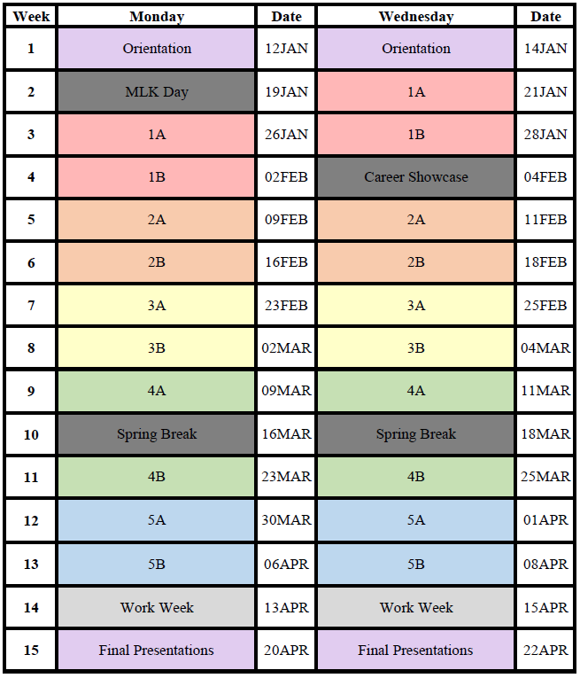
*Note that this schedule is subject to change due to weather events and other unforeseen circumstances. Notifications of changes will be sent via Canvas announcements.

Attendance Policy, Class Expectations, and Make-Up Policy
- Students are required to attend all lab sessions.
  - Excused absences must be consistent with policies (see below) and require documentation.
  - You must inform me by 10am on the day of the absence. Failure to do so will result in the absence remaining unexcused.
  - The earlier you tell me, the easier it will be for me to excuse the absence and to figure out make-up sessions.
- Unexcused absences and tardiness will result in a grade reduction.
  - One unexcused absence will result in a 10% total grade reduction. Two unexcused absences will result in failure of the course.
  - One instance of tardiness will not be penalized. Two or more instances of tardiness will result in 5% total grade reduction per instance. For example, if you are late twice, you will receive a 10% total grade reduction.
- Both unexcused and excused absences require a make-up session.
  - This can be done either by joining another group on a different day (i.e. showing up on Thursday if you’re a Wednesday student) or scheduling a make-up lab with other students who missed the same experiment during the last week of the semester.
  - This will not remove grade penalties associated with the absence.

While this may seem strict, please remember that there are only 10 lab sessions (not including the first day or final presentations). Missing one or two days means that you miss a large percentage of the course content. Being late or absent also hurts your teammates, who will have to do extra work during lab and spend more time filling you in later.

Requirements for class attendance and make-up exams, assignments, and other work in this course are consistent with university policies. Click here to read the university attendance policies:
https://catalog.ufl.edu/UGRD/academic-regulations/attendance-policies/

Safety
Students are expected to follow safe operating procedures of equipment as well as proper handling of hazardous materials. Students are required to attend safety training at the start of the semester. Failure to follow safe operating procedures will result in a grade reduction. Examples of violations are listed below (not exhaustive):
Safety violation | Penalty
Leaving the lab without shutting down an experimental system | Failing grade
Pulling the safety shower without a valid reason | Letter grade reduction
Not wearing PPE required by an experiment | Letter grade reduction
Not disposing of hazardous waste properly | Letter grade reduction
Consuming food, gum, or a beverage in the lab | Letter grade reduction

Evaluation of Grades
Assignment | Points
Module x5 | 150 each^
Final presentation^ | 100
Participation* | 200
Total | 1000
^Final presentation replaces the final memo for Module E. Module E is therefore worth 200 points in total, instead of 150.
*Participation includes evaluation of your lab assistants and peers (submissions as well as results), and instructor assessment.

Module | Points
Pre-Lab | 25
Experimental Design | 25
Memo #1 | 50
Memo #2 | 50

Grading Policy
Percent | Grade | Grade Points
93.4 - 100 | A | 4.00
90.0 - 93.3 | A- | 3.67
86.7 - 89.9 | B+ | 3.33
83.4 - 86.6 | B | 3.00
80.0 - 83.3 | B- | 2.67
76.7 - 79.9 | C+ | 2.33
73.4 - 76.6 | C | 2.00
70.0 - 73.3 | C- | 1.67
66.7 - 69.9 | D+ | 1.33
63.4 - 66.6 | D | 1.00
60.0 - 63.3 | D- | 0.67
0 - 59.9 | E | 0.00

Cooperation Policy
- Students are expected to work in teams on their experiments, specifically experimental designs and memos.
- Individual assignments, specifically pre-labs and any extra credit work, should be completed by each student individually.

Plagiarism
Students are not permitted to represent as their own work any portion of the work of another person. Plagiarism includes (but is not limited to) submitting a document or assignment which in whole or in part is identical or substantially identical to a document or assignment not authored by the student. All sources used in preparation of the reports should be cited, including the manuals provided on Canvas. Failure to do so is considered plagiarism. Note that self-plagiarism is also an issue and will be punished as if the student plagiarized someone else’s work. You must cite any figures or information taken from other reports. This is the academic standard and is largely due to journal copyright issues when publishing papers.

Falsification of Information
Students are not permitted to use or report any invented or fabricated information or data. This includes both experimental results and theoretical calculations.

Sanctions for Violations of Honor Code
Since ethical behavior in science and engineering is equal in importance to specific knowledge, the instructor will assign a non-passing letter grade to students who violate academic honesty standards, regardless of the violator's grade performance in class.

Academic Policies & Resources
To support consistent and accessible communication of university-wide student resources, instructors must include this link to academic policies and campus resources: https://go.ufl.edu/syllabuspolicies. Instructor-specific guidelines for courses must accommodate these policies.

Commitment to a Positive Learning Environment
The Herbert Wertheim College of Engineering values varied perspectives and lived experiences within our community and is committed to supporting the University’s core values.

If you feel like your performance in class is being impacted, please contact your instructor or any of the following:
• Your academic advisor or Undergraduate Coordinator
• HWCOE Human Resources, 352-392-0904, student-support-hr@eng.ufl.edu
• Pam Dickrell, Associate Dean of Student Affairs, 352-392-2177, pld@ufl.edu

